FOR IMMEDIATE RELEASE

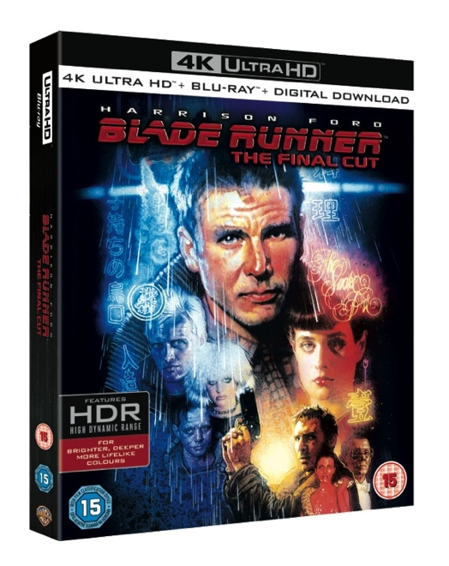
BLADE RUNNER: THE FINAL CUT

4K UHD, 4K UHD SPECIAL EDITION AND BLU-RAY™ STEELBOOK.

SIR RIDLEY SCOTT’S SCI-FI CLASSIC STARRING HARRISON FORD TO BE AVAILABLE IN 4K RESOLUTION WITH HIGH DYNAMIC RANGE (HDR)
TIMED TO THE FILM’S 35TH ANNIVERSARY

Warner Bros. Home Entertainment announced today that to celebrate the 35th anniversary of the sci-fi classic, Blade Runner: The Final Cut will be released on 4K UHD on September 4th, 4K UHD Special Edition on September 25th and Blu-ray™ Steelbook on November 13th. Directed by Sir Ridley Scott (Gladiator, The Martian, Alien Covenant) and starring Harrison Ford (the upcoming Blade Runner 2049) as Rick Deckard, Blade Runner is widely accepted as one of the most important science-fiction movies of the 20th Century with immeasurable influence on society for its futuristic depiction of a post-apocalyptic, dystopian world. The film has appeared on more ‘Top Five’ sci-fi lists than any other film.
Blade Runner: The Final Cut features restored and remastered original elements, added/extended scenes, added lines, new and improved special effects, and director and filmmaker commentary.
Upon it’s original release in 2007, director Ridley Sir Ridley Scott said: "The Final Cut is the product of a process that began in early 2000 and continued off and on through seven years of intense research and meticulous restoration, technical challenges, amazing discoveries and new possibilities. I can now wholeheartedly say that Blade Runner: The Final Cut is my definitive director’s cut of the film."
UHD showcases 4K resolution with High Dynamic Range (HDR) and a wider color spectrum, offering consumers brighter, deeper, more lifelike colors for a home entertainment viewing experience like never before.
For the complete 4K UHD experience with HDR, a 4K UHD TV with HDR, a UHD Blu-ray™ player and a high-speed HDMI (category 2) cable are required.
The UHD Blu-ray™ disc of Blade Runner: The Final Cut will feature a Dolby Atmos® soundtrack remixed specifically for the home theatre environment to place and move audio anywhere in the room, including overhead. To experience Dolby Atmos at home, a Dolby Atmos enabled AV receiver and additional speakers are required, or a Dolby Atmos enabled sound bar; however, Dolby Atmos soundtracks are also fully backward compatible with traditional audio configurations and legacy home entertainment equipment.
Blade Runner: The Final Cut will be available on 4K UHD and features an UHD Blu-ray™ disc with the feature film in 4K with HDR and a Blu-ray™ disc of Blade Runner: The Final Cut.
Fans can also own Blade Runner: The Final Cut in 4K UHD Special Edition which includes the 4K UHD Final Cut, four finished versions of the film (including the Original Theatrical Cut, International Theatrical Cut and Director's Cut), the Workprint Feature Version, Documentary Dangerous Days and an exclusive art book with behind-the-scenes photos, production art, sketches and storyboards. Blade Runner: The Final Cut Steelbook will also be available.

SYNOPSIS

21st-century detective Rick Deckard brings his masculine-yet-vulnerable presence to this stylish noir thriller. In a future of high-tech possibility soured by urban and social decay, Deckard hunts for fugitive, murderous replicants – and is drawn to a mystery woman whose secrets may undermine his soul.

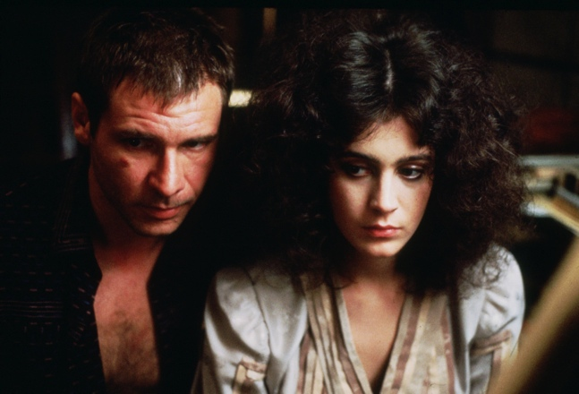

4K UHD ELEMENTS

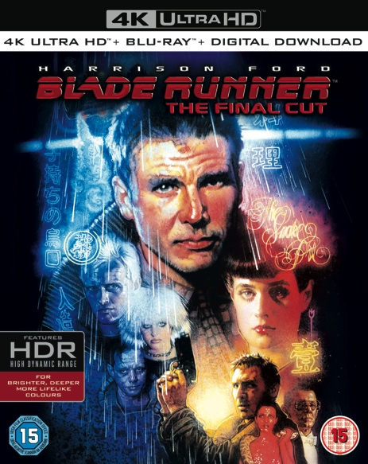

Blade Runner: The Final Cut 4K UHD contains the following special features:

- Introduction by Ridley Scott
- Three Filmmaker Commentaries, Including One by Ridley Scott

4K UHD SPECIAL EDITION ELEMENTS

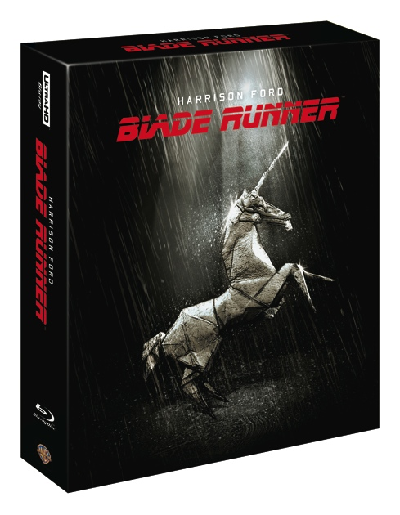

4K UHD Disc
- Final Cut Feature
- Intro by Ridley Scott
- Commentary by Ridley Scott
- Commentary by Screenwriters
- Commentary by Technical Crew

Blu-ray™ Disc 1
- Final Cut Feature
- Intro by Ridley Scott
- Commentary by Ridley Scott
- Commentary by Screenwriters
- Commentary by Technical Crew

Blu-ray™ Disc 2
- Director's Cut
- Original Domestic cut
- Original International Theatrical Cut
- Intro by Ridley Scott Director's Cut
- Intro by Ridley Scott Original Domestic cut
- Intro by Ridley Scott Original International Theatrical Cut

Blu-ray™ Disc 3
- Workprint featurette
- Workprint introduction by Ridley Scott
- Workprint commentary by future noir author Paul M. Sammon
- Dangerous Days: Making Blade Runner documentary
- The Electric Dreamer: Remembering Philip K. Dick featurette
- Sacrificial Sheep: The Novel vs. The Film featurette
- Philip K. Dick: The Blade Runner Interviews featurette
- Signs of the Times: Graphic Design featurette
- Fashion Forward: Wardrobe and Styling featurette
- Screen Tests: Rachel and Pris featurette
- The Light That Burns: Remembering Jordan Cronenweth featurette
- Deleted and Alternate Scenes - Including introduction by Ridley Scott
- On the Set featurette
- Convention reel
- Behind-the-scenes outtakes
- 1981 teaser trailer
- 1982 theatrical trailer
- 1982 TV spot - trailers and TV spot
- 1992 Director's Cut trailer
- 2007 Dangerous Days teaser trailer
- 2007 Final Cut trailer
- Promoting Dystopia: Rendering the Poster Art featurette
- Deck-A-Rep: The True Nature of Rick Deckard featurette
- Nexus Generation: Fans & Filmmakers featurette
- All Our Variant Futures: From Workprint to Final Cut featurette
- Blade Runner Stills Gallery ## 1,042 Images

BLU-RAY™ STEELBOOK ELEMENTS
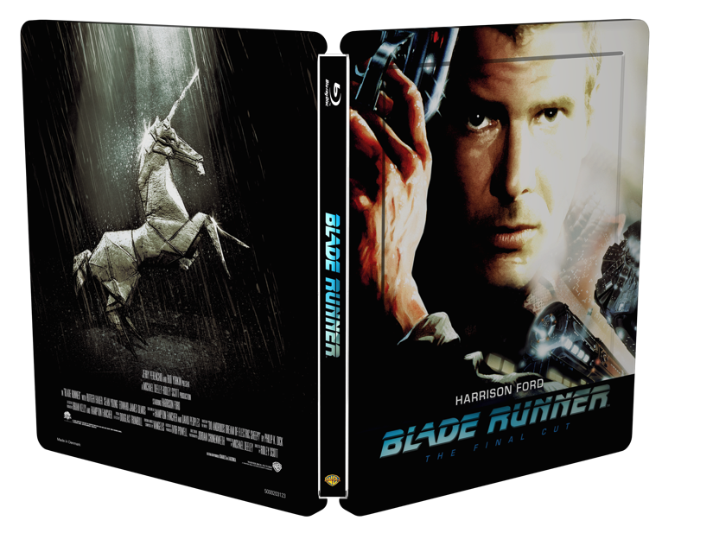

- Introduction by Ridley Scott and Three Filmmaker Commentaries, Including One by Ridley Scott.
- Dangerous Days: Making Blade Runner - Definitive Documentary Incorporating Outtakes, Deleted Scenes and Interviews. The Ultimate Look at the Movie's Difficult Creation and Controversial Legacy.

BASICS
PRODUCT SRP
4K UHD £28.59
4K UHD SPECIAL EDITION £51.05
BLU-RAY™ STEELBOOK £29.59

4K UHD release date: September 4, 2017
4K UHD Special Edition release date: September 25, 2017
Blu-ray™ Steelbook release date: November 13, 2017

4K UHD Languages: Blu-ray™ Main Feature: English, Castilian Spanish, Danish, Dutch, Finnish, French, German, Italian, Norwegian, Portuguese & Swedish. 4K UHD Main Feature: Dolby Atmos TrueHD: English; Dolby Digital: Brazilian Portuguese 5.1, Czech 5.1, French 5.1, German 5.1, Italian 5.1, Polish 5.1, Russian 5.1, Latin Spanish 2.0.

4K UHD Special Edition Languages: Blu-ray™ Main Feature: Dolby Digital: English 5.1, Castilian Spanish 5.1, French 5.1, German 5.1, Italian 5.1.4K UHD Main Feature: Dolby Atmos TrueHD: English; Dolby Digital: Brazilian Portuguese 5.1, Czech 5.1, French 5.1, German 5.1, Italian 5.1, Polish 5.1, Russian 5.1, Latin Spanish 2.0.

Blu-ray™ Steelbook Languages:Blu-ray Main Feature: Dolby Digital: English 5.1, Castilian Spanish 5.1, French 5.1, German 5.1, Italian 5.1.

Running Time: 117 mins
Certificate: 15
DOLBY ATMOS (CC)

CREDITS

About Warner Bros. Home Entertainment, Inc.
Warner Bros. Home Entertainment (WBHE) brings together Warner Bros. Entertainment's home video, digital distribution and interactive entertainment businesses in order to maximize current and next-generation distribution scenarios. An industry leader since its inception, WBHE oversees the global distribution of content through packaged goods (Blu-ray Disc™ and DVD) and digital media in the form of electronic sell-through and video-on-demand via cable, satellite, online and mobile channels, and is a significant developer and publisher for console and online video game titles worldwide. WBHE distributes its product through third party retail partners and licensees.

PUBLICITY CONTACTS

Thomas Hewson
0203-405-4312 / tom@fetch.fm
Artwork and additional assets available from: www.fetch.fm

-wbhe-

