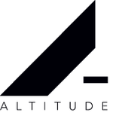

IS DELIGHTED TO ANNOUNCE THE UK & IRISH RELEASE OF

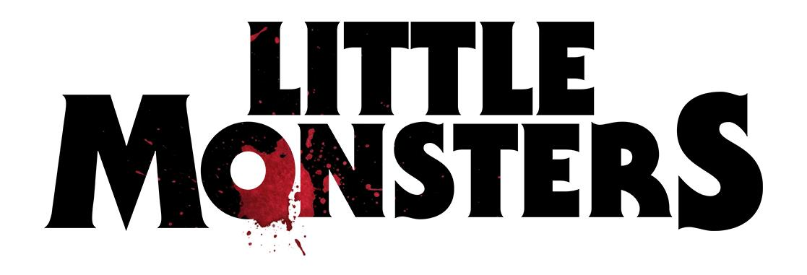
STARRING ACADEMY AWARD® WINNER LUPITA NYONG’O, FROM
12 YEARS A SLAVE AND US, AND FROZEN’S JOSH GAD
IN UK & IRISH CINEMAS AND ON SKY CINEMA FROM
15 NOVEMBER
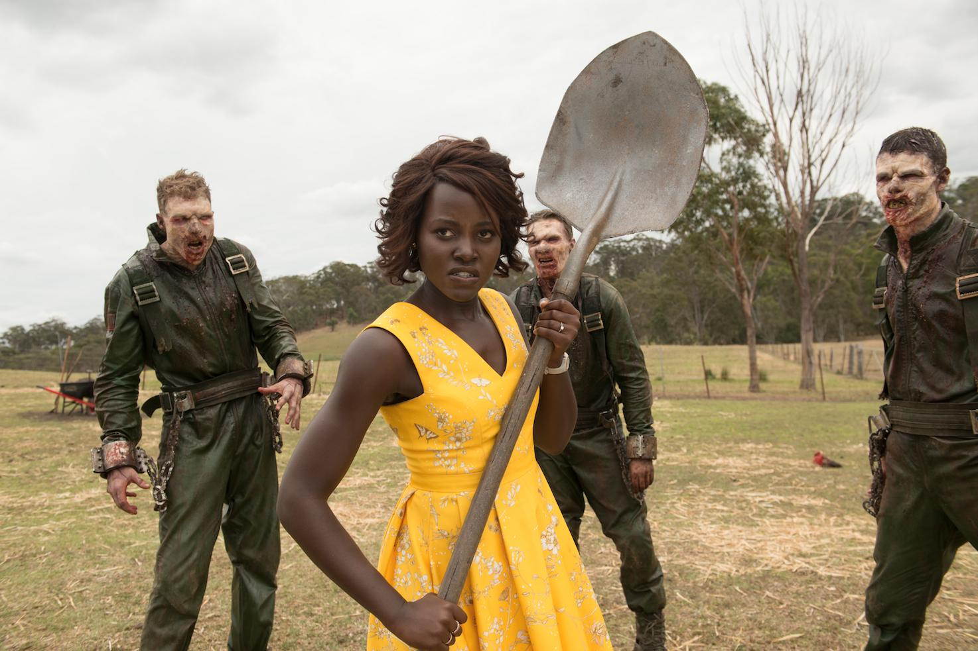
Official UK Red-Band Trailer
Official Poster
LONDON, 31 JULY 2019 – On 15 November 2019, Lupita Nyong’o, fresh from the success of Jordan Peele’s Us, returns to the screens in another brilliantly inventive and fantastically entertaining horror comedy, LITTLE MONSTERS - but this time with laughs and musical numbers! Also starring Josh Gad (Olaf from Frozen) and Alexander England (Alien: Covenant), this is the funniest zombie horror since Shaun of the Dead, bolstered by a knowing self-awareness and an uproarious script.
Little Monsters follows Dave (Alexander England), as washed-up musician who volunteers to chaperone his nephew’s kindergarten class field trip after taking a serious liking to the fearless schoolteacher, Miss Caroline (Lupita Nyong’o). Dave’s intentions are complicated by the presence of the world’s most famous kids’ show personality and competition for Miss Caroline’s affections, Teddy McGiggle (Josh Gad).
One thing none of them bargained for, however, is a sudden zombie outbreak. Will Dave rise to the occasion and have a chance at Miss Caroline’s heart, or will zombies get there first?
Described as a ‘must-see horror comedy’ by We Got This Covered, and a ‘thrill-ride’ by Screen International, Sundance Hit LITTLE MONSTERS is a smart, sharp and deliciously gruesome zom-com that will appeal to fans of the Zombieland films, What We Do in the Shadows and Happy Death Day. Doused with a generous helping of absurdity, pitch-perfect timing, and a nifty blend of gore and wit, it’s a wild, frenetic ride.
Award-winning writer/director Abe Forsythe has struck gold with his cast - Lupita Nyong’o is currently the horror genre’s hot ticket, following her standout performance in Jordan Peele’s Us, which played no small part in making that film a box office smash this year. Josh Gad, famous for his loveable roles in Disney films Frozen and Beauty and the Beast, is on fabulous form here playing against type.
LITTLE MONSTERS comes from the production team behind cult chillers The Guest and You’re Next, and the 2016 Blair Witch remake (as well as the forthcoming reboot of Korean revenge thriller I Saw The Devil), with special effects from the Oscar-winning studio behind Mad Max: Fury Road. The film will be released in cinemas across the UK and Ireland by Altitude Film Entertainment.
www.facebook.com/LittleMonstersMovieUK www.twitter.com/LMMovieUK www.instagram.com/LittleMonstersMovieUK
#LittleMonsters
For interview requests & further information, please contact Fetch Publicity
Sadari Cunningham - Sadari@fetch.fm
Lisa DeBell - Lisa@fetch.fm
0203 405 4312
NOTES TO EDITORS
ALTITUDE FILM ENTERTAINMENT - The Altitude Film Entertainment group comprises of the vertically integrated Altitude Film Production led by Will Clarke chairman and joint-CEO with Andy Mayson; Altitude Film Sales with Managing Director Mike Runagall; and Altitude Film Distribution with Head of Distribution Hamish Moseley.
Altitude’s sales slate includes:
Billie directed by award-winning filmmaker James Erskine and produced by Victoria Gregory and Barry Clark-Ewers; SAS: RED NOTICE directed by Magnus Marten and starring Sam Heughan; Ruby Rose; Andy Serkis; Hannah John-Kamen; Tom Hopper; Noel Clarke and Tom Wilkinson; The Power by BAFTA-nominated writer-director Corinna Faith and starring Rose Williams; Calm with Horses directed by Nick Rowland and starring Cosmo Jarvis; Barry Keoghan; Ned Dennehy and Niamh Algar; Horrible Histories the Movie: Rotten Romans directed by Dominic Brigstocke and starring Craig Roberts; Kim Cattrall; Nick Frost; Kate Nash and Sir Derek Jacobi; Black 47, directed by Lance Daly and starring Hugo Weaving, Jim Broadbent, James Frecheville, Stephen Rea, Freddie Fox, Barry Keoghan, Moe Dunford and Sarah Greene, which received its World Premiere Out of Competition at the Berlin International Film Festival 2018, Rocks directed by BAFTA-nominated filmmaker Sarah Gavron and starring Bukky Bakay-Odeyemi; Kosar Ali and Shaneigha Greyson; Simon Bird’s directorial debut Days of the Bagnold Summer starring Monica Dolan; Earl Cave; Rob Brydon; Alice Lowe and Tamsin Greig; Sulphur and White directed by BAFTA-nominated Julian Jarrold and starring Mark Stanley; Emily Beecham; Anna Friel and Dougray Scott; Chasing Chaplin from BAFTA and Sundance nominated filmmakers Peter Middleton and James Spinney; Diego Maradona; the third film from the Academy Award® and multi BAFTA-winning team led by director Asif Kapadia; Hallelujah! directed by Chris Addison and starring Academy Award® nominated Ralph Fiennes; Beats directed by Brian Welsh and executive produced by Academy Award®-winning director Steven Soderbergh; Ghost Stories, directed by Jeremy Dyson and Andy Nyman based on their international smash hit starring Martin Freeman, Alex Lawther and Paul Whitehouse; Great White directed by Martin Wilson; Carmila directed by Emily Harris; with music by Radiohead’s Philip Selway and starring Jessica Raine; Tobias Menzies and Greg Wise; Guns Akimbo directed by Jason Lei Howden and starring Daniel Radcliffe and Samara Weaving; Liam Gallagher: As It Was directed by Charlie Lightening and Gavin Fitzgerald; and Black Water Abyss directed by Andrew Traucki.
Since launching in 2013 Altitude Film Distribution have proudly supported talented filmmakers and given their films the dynamic and bold releases they deserve in the UK and Ireland.
To date Altitude have championed over 100 films, ranging from the Academy and BAFTA award winning Moonlight, 20 Feet From Stardom, Amy, I Am Not Your Negro and through to critically acclaimed The Florida Project, Lady Macbeth, Beast, The Rider, Whitney and more.
Altitude’s most recent releases include Horrible Histories: The Movie – Rotten Romans, Asif Kapadia’s Diego Maradona, Charlie Lightening and Gavin Fitzgerald’s Liam Gallagher: As It Was, A Private War starring Rosamund Pike as war correspondent Marie Colvin, the acclaimed Being Frank: The Chris Sievey Story, Jonah Hill’s Mid90s, David Fairhead’s Armstrong and Brian Welsh’s Beats. Altitude also partnered with platinum selling artist Drake on the release of Reinaldo Marcus Green’s Monsters and Men in January 2019.
Forthcoming releases include, Sarah Gavron’s Rocks, Chasing Chaplin from BAFTA nominees Peter Middleton and James Spinney, Nick Rowland’s Calm With Horses, Andre Singer and Werner Herzog’s Meeting Gorbachev, Little Monstersstarring Lupita Nyong’o, animated family adventure Asterix: The Secret Of The Magic Potion, Simon Bird’s Days of the Bagnold Summer and Horrible Histories: The Movie – Rotten Romans and Beards from director David Freyne.

Twitter @AltitudeFilms
Facebook Facebook/AltitudeFilmDistribution
Instagram @altitudefilmUK
Altitude on YouTube

