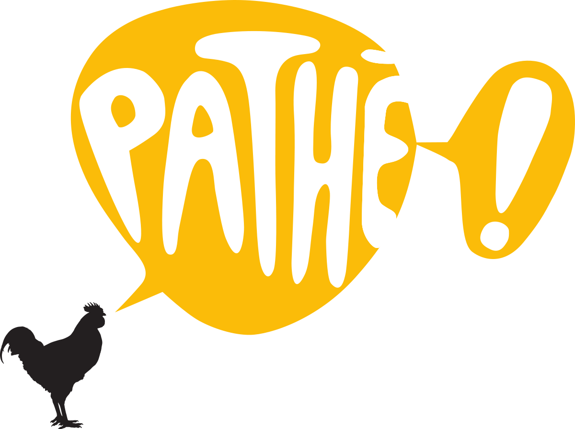
Golden Globe Nominee Renée Zellweger’s
JUDY debuts on digital download on
25th January and on Blu-ray & DVD on 3rd February
JUDY, starring Entertainment Weekly’s Entertainer of the Year, and Academy Award® and BAFTA-winner Renée Zellweger, as Hollywood singing legend Judy Garland, can be yours to own from 25th January on Digital Download and on DVD & Blu-ray from 3rd February.
BAFTA-nominated director Rupert Goold’s film has already won 2 BIFAs, and been nominated for a Golden Globe and a Screen Actors Guild award, as well as 3 London Critics’ Circle Film Awards including ‘Actress Of The Year’. Zellweger’s stunning portrayal of the troubled star has been described as “spine-tingling” (Brian Viner, Daily Mail), “the performance of a lifetime” (The Independent), and “joyous” (Attitude); and the film has garnered 5-star raves from the Daily Express, Daily Star and Little White Lies.
Synopsis
Winter 1968, and showbiz legend Judy Garland arrives in London, to perform in a sell-out run at The Talk of the Town. It is 30 years since she shot to global stardom in The Wizard Of Oz, but if her voice has weakened, its dramatic intensity has only grown.
As she prepares for the show, battles with management, charms musicians, and reminisces with friends and adoring fans, her wit and warmth shine through. Even her dreams of romance seem undimmed, as she embarks on a courtship with Mickey Deans, her soon-to-be fifth husband.
And yet Judy is fragile. After working for 45 of her 47 years, she is exhausted; haunted by memories of a childhood lost to Hollywood; gripped by a desire to be back home with her kids. Will she have the strength to go on? Featuring some of her best-known songs, the film celebrates the voice, the capacity for love, and the sheer pizzazz of “the world’s greatest entertainer”.
Judy Special Features (Blu-ray & DVD)
• Behind The Scenes Featurette
• Transformation: Becoming Judy Featurette
• 3 Deleted Scenes
For further information contact:
Fetch Publicity
Sadari Cunningham
T: +44 (0) 203 405 4312
E: Sadari@fetch.fm
ABOUT PATHÉ
Pathé operates as a film studio in France, the UK, the Netherlands and Switzerland. It is involved in all aspects of filmmaking, from development and production through to international sales, distribution and exhibition.
Films produced/distributed by Pathé range from The Queen to Slumdog Millionaire and from Philomena to Selma. Pathe’s most recent production is Judy starring Renee Zellweger. In recent years Pathé’s productions have won 16 BAFTAs (66 nominations) and 13 Oscars (46 nominations).
Pathé International handles the international marketing and sales of Pathé’s own productions and also acquires third party films for worldwide representation. As one of Europe’s leading sales agents, Pathé International has a significant presence at all major film markets and festivals.
www.pathe.co.uk
@patheuk

###

