For Immediate Release

&
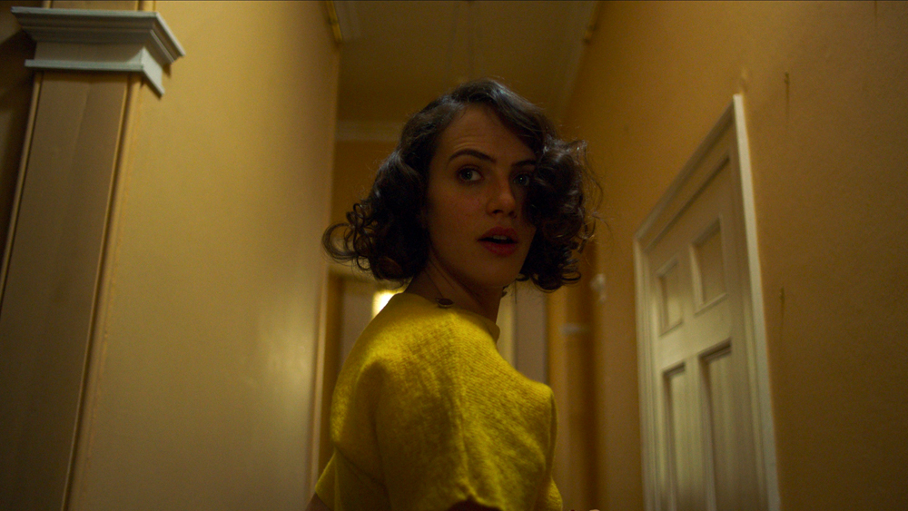
CHRISTOPHER SMITH’S NEW CHILLER THE BANISHING HITS
UK CINEMAS AND DIGITAL PLATFORMS MARCH 26TH

JESSICA BROWN FINDLAY CONFRONTS HER DEMONS IN CHRISTOPHER SMITH’S NEW SUPERNATURAL HORROR

“One of the best haunted house films we've seen for a while” - Starburst

5TH JANUARY 2020, LONDON UK: The Shining meets Downton Abbey in the chilling new ghost story THE BANISHING, starring Jessica Brown Findlay (Brave New World, Harlots) and directed by genre master Christopher Smith (Black Death, Severance, Triangle). THE BANISHING will be released in cinemas and on digital platforms March 26th 2021, courtesy of AMC Networks’ Shudder, in partnership with Vertigo Releasing.

THE BANISHING has a terrific cast, including Downton Abbey’s Brown Findlay as a young woman uncovering dark secrets in her new home; Sean Harris (Red Riding, Mission: Impossible) as ghost hunter Harry Price; and John Lynch (Isolation) as a sinister ‘man of God’. Smith expertly delivers a handsomely mounted period mystery, based around the spooky real life Borley Rectory tale, that steadily builds to a satisfying climax, twanging the nerves along the way, with creepy dolls, shadowy figures, religious mania and the terror of madness. A story of isolation and a family strained to breaking point, THE BANISHING is the perfect lockdown-era chiller for fans of spine-tinglers like The Others and Rebecca.

Synopsis: 1930s, England. Linus, his wife Marianne and their daughter Adelaide move into town, where Linus has been posted as the new reverend. He’s been tasked by the Church to renew the villagers’ faith, which has been lost after the disappearance of the previous reverend’s family, who lived in the very same mysterious manor where Linus and his family have settled into. Soon after their arrival, strange events start to occur: ghostly voices, dark figures dressed as monks, mysterious totems, and Adelaide’s behavior becoming stranger by the day. It soon becomes clear that a malicious entity seeks to possess Adelaide and that the Church is hiding a terrible secret…

THE BANISHING will be released in cinemas and on digital platforms March 26th 2021

Facebook.com/Shudder
Twitter.com/Shudder
Twitter.com/Shudder_UK
Instagram.com/Shudder

Facebook.com/VertigoReleasingUK
Twitter.com/VertigoRel
Instagram.com/VertigoReleasing

For more information please contact:
Sadari Cunningham | sadari@fetch.fm
For stills, press notes and more please visit www.fetch.fm

ABOUT SHUDDER
AMC Networks’ Shudder is a premium streaming video service, super-serving members with the best selection in genre entertainment, covering horror, thrillers and the supernatural. Shudder’s expanding library of film, TV series, and originals is available on most streaming devices in the US, Canada, the UK, Ireland, Germany, Australia and New Zealand. For a 7-day, risk-free trial, visit ​www.shudder.com​.

ABOUT VERTIGO
Vertigo Releasing is committed to discovering and championing the most important part of film: the talent. Our releases have grossed over $80 million at the UK box office. We have won multiple awards for our innovative campaigns for quality independent films such as The Assistant, The Miseducation of Cameron Post, Child’s Play, Death Wish, Mrs Lowry & Son, Hunt for the Wilderpeople, Springbreakers, Horrid Henry, Streetdance, Bronson, Top Cat the Movie, The Time of Their Lives and Monsters.

