FOR IMMEDIATE RELEASE
London UK, 10th November 2021

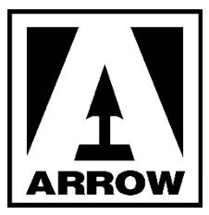

GRAB YOUR POPCORN AND DIM THE LIGHTS FOR
THE LAST MATINEE

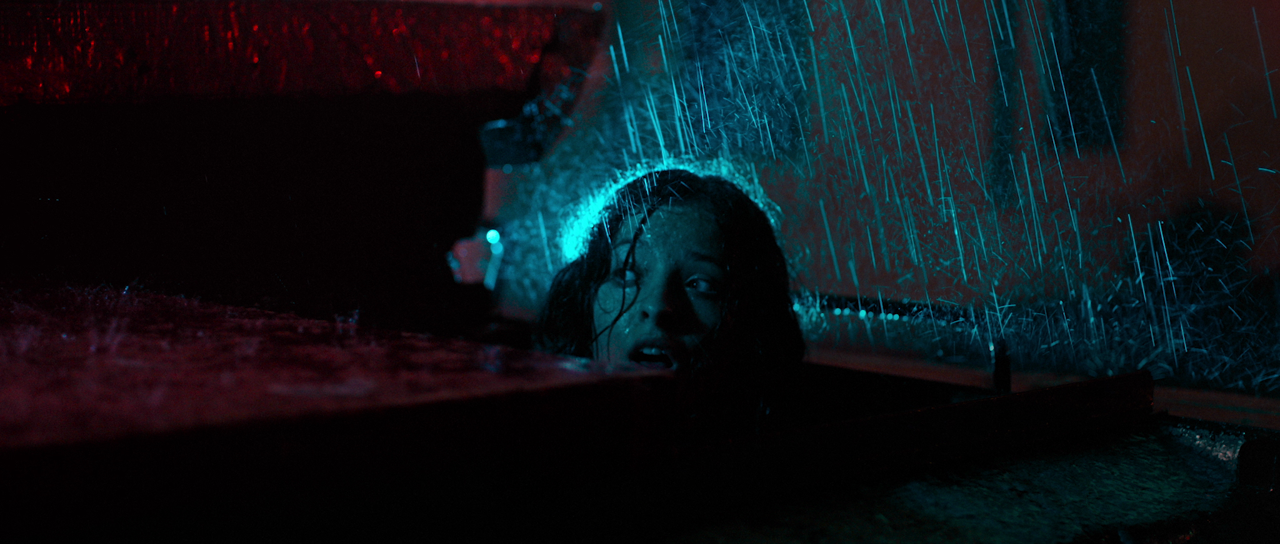
ARROW PREMIERES A CINEMA-SET GIALLO-SLASHER
“Genuinely tense and suspenseful with more than a few moments of jaw-dropping gore.”
- Grace Detwiler, Rue Morgue

“A solid slasher that the monster kid in me would have loved to take home ” - Ian Sedensky, Culture Crypt

“A superior celluloid slasher” - Rob Aldam, Backseat Mafia

“A blood-soaked and nostalgic journey into a bygone era” - Amanda Mazzillo, Film Inquiry

On December 1st 2021, the essential, alternative streaming service ARROW premieres THE LAST MATINEE, a stylish neo-giallo love letter to classic slashers that will send your popcorn flying and have you diving behind your seat!
Uruguayan director Maxi Contenti marks himself out as a talent to watch with a film that is a killer time at the movies! The film will also be released on Limited Edition Blu-ray, including six short films by Contenti, as well as a collectors’ booklet and a fold-out poster, on December 6th.

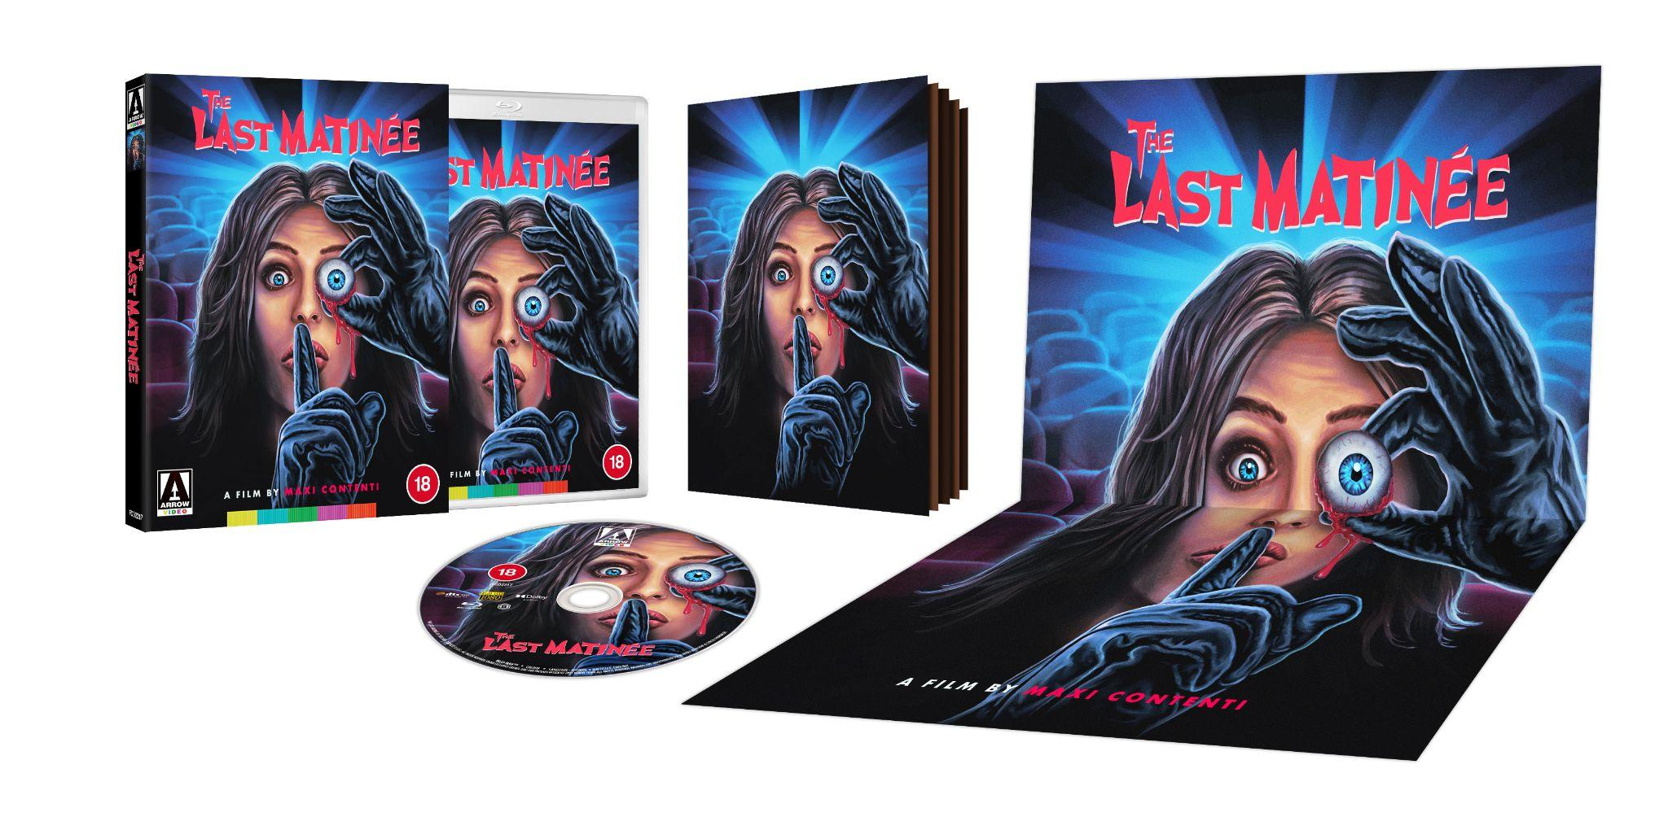

With lavish retro visuals, inventive and unexpected kills, buckets of grisly gore, a throbbing synth-drenched score, and a superb setting in a fleapit cinema, this is a fright-film lover’s dream - a blend of 80s slasher with Argento giallo, replete with a black-hooded, eyeball-plucking killer and a final girl, Luciana Grasso, you’ll be cheering for. THE LAST MATINEE ticks all the right boxes for devoted horror hounds: it’s Demons, Halloween, StageFright, Popcorn, Opera and Drive in Massacre all rolled into one superbly sinister reel and projected for your delight.

ARROW’s exclusive presentation of THE LAST MATINEE will include an audio Commentary with Director Maxi Contenti; behind the scenes footage; a VFX featurette exploring the special effects of the film; an interview with director Contenti; Killer Attractions: Maxi Contenti & Ricardo Islas in Conversation, a discussion between the film’s director and star Ricardo Islas, director of Frankenstein: Day of the Beast; At the Premiere, a featurette on the film’s premiere; The Matinee Massacre, a 3 part series of ‘mockumentary’ shorts exploring the events of the movie as if they really happened; and the trailer.
Synopsis:

A cold, wet day. A declining cinema. All you want is to get out of the rain and watch a good film. But who else is in there, hiding in the dark? When Ana takes over projection duties from her ailing father, she doesn’t expect anything worse than a broken reel or a burned-out bulb. But there’s a sadistic killer in the auditorium, and soon blood is running in the aisles as he starts picking off the audience members one by one. Can Ana and the few remaining survivors escape the murderous madman, or will they be victims of his matinee massacre?

Watch THE LAST MATINEE first: head to ARROW and start your 30-day free trial. Available on the following Apps/devices: Xbox, Roku (all Roku sticks, boxes, devices, etc), Apple TV; iOS devices, Android TV and mobile devices, Fire TV (all Amazon Fire TV Sticks, boxes, etc), and on all web browsers at www.ARROW-Player.com.

Subscriptions are available for £4.99 monthly or £49.99 annually

THE LAST MATINEE will also be released on Limited Edition Blu-ray on 6th December

For more information contact:

Fetch Publicity

Sadari Cunningham | sadari@fetch.fm
Please contact Sadari Cunningham for access to a screening link for ARROW.

Tom Hewson | tom@fetch.fm
Please contact Tom Hewson for access to review discs for the Blu-ray release.

YouTube
Instagram
Twitter
Facebook

About ARROW
From Arrow Films, a recognised world-leader in curation and creation, ARROW [formerly known as ‘Arrow Video Channel’] is a premium platform giving you an unparalleled viewing experience across multiple devices, so you can explore the films and TV shows that the Arrow brand is famous for.
Specially curated by members of the ARROW team, ARROW will be home to premium film and TV entertainment, exclusive new premieres, cutting edge cinema, international classics and cult favourites - such as the works of Lars Von Trier, Brian De Palma, Dario Argento, David Cronenberg and Park Chan-wook - plus the very best in acclaimed TV series, including The Bridge and Italian crime series Gomorrah, and brand-new short films from both new and established filmmakers. In the coming months, ARROW will be adding Oscar-winning hits, European classics, Asian cinema masterworks, rediscovered Westerns, offbeat gems and much more, along with such festival favourites Dementer and Dinner in America as part of ARROW’s international strategy to support and celebrate the medium of film.
ARROW will also be home to ARROW Stories - an ever-growing collection of interviews, trailers, documentaries and additional extras, newly created just for the service and from its extensive archives. The service will be updated regularly with fresh content, new curation focuses and never-before-seen content, all selected by the ARROW team as well as the filmmakers themselves. With a slickly designed and user-friendly interface ARROW is the new alternative place to go for the very best in On-Demand entertainment.

