For Immediate Release

CANNES FILM FESTIVAL AWARD WINNER
PETROV’S FLU

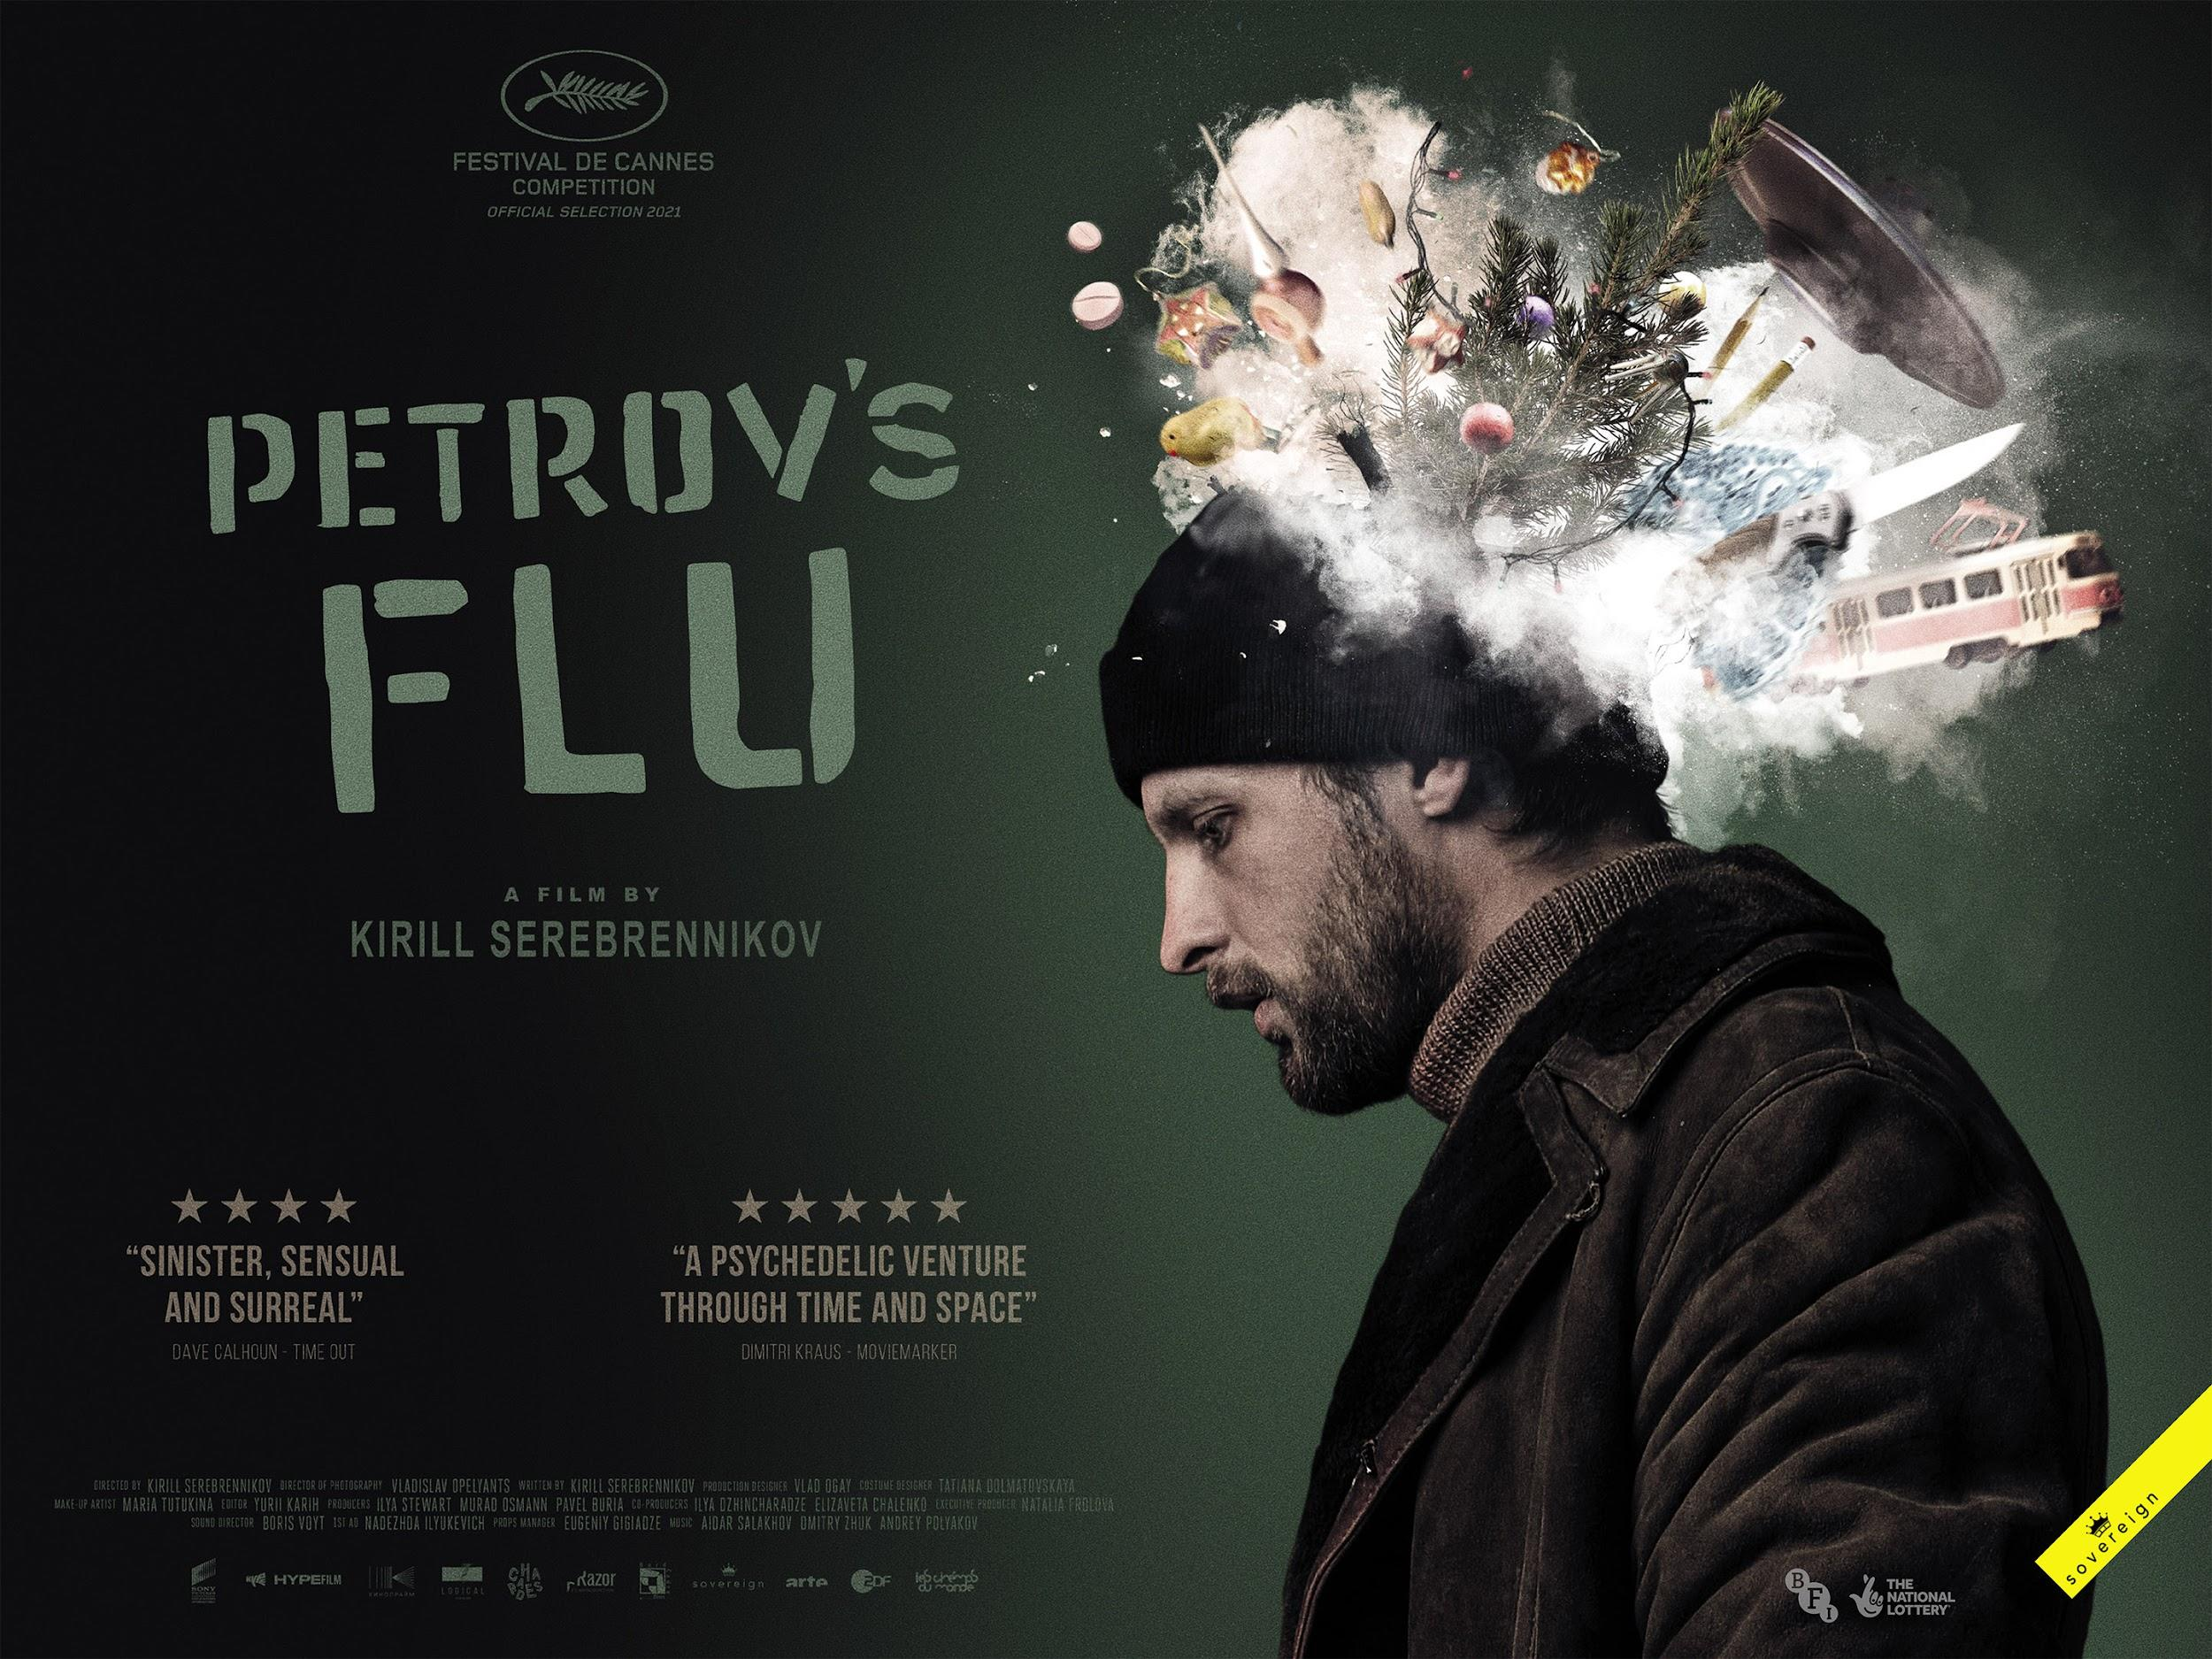
"Ambitious, eccentrically amusing and visually flamboyant"
Demetrios Matheou, Screen Daily

"Pure cinematic punk-rock... Wildly audacious"
Shaun Munro, Flickering Myth

"Sinister, sensual and surreal" 4 stars
Dave Calhoun, Time Out

"Breathtaking filmmaking"
Mark Asch, Little White Lies

"A rowdy, exhilarating return to top form for Serebrennikov"
Guy Lodge, Variety

“Skillfully executed and mesmeric”
Leslie Felperin, The Hollywood Reporter

“A formidable piece of filmmaking”
Ben Kroll, The Wrap

“A breathtakingly bold and effortlessly brilliant piece of cinema"”
Rob Aldam, Backseat Mafia

HALLUCINATORY SCI-FI DRAMA RELEASED IN UK 11 February 2022

22nd January 2021, London UK - SOVEREIGN is proud to announce the release of controversial Russian director Kirill Serebrennikov’s Cannes prize-winner, the sci-fi drama Petrov’s Flu, on February 11th 2022 in UK cinemas.

A deadpan, hallucinatory romp through post-Soviet Russia, based on the novel The Petrovs In and Around the Flu by Alexey Salnikov, the film details a surreal and fantastic day in the life of a comic book artist and his family. It won the prestigious CTS Artist award at this year’s Cannes Film festival, for Vladislav Opelyants' virtuoso cinematography and was nominated for the Palme d’Or. The film was also selected to play in the ‘Dare’ section of this year’s BFI London Film Festival. It is being released with the support of the BFI, awarding funds from the National Lottery in order to bring this project to more audiences across the UK.

Director Serebrennikov’s film The Student (2016) competed for the Un Certain Regard at the Cannes Film Festival and went on to win the Francois Chalais prize. His previous film, Leto (2018) was part of the main Competition at Cannes and was awarded the ‘personal Palme d’Or’ by Le Figaro magazine. He wrote Petrov’s Flu while he was under house arrest in Russia.

The result is a very crazy, very Russian and an extremely violent and unique experience that is in turns shocking and disturbing, explicit, touching and visually stunning, appealing to fans of everything from sci-fi, action to provocative arthouse. A weird, wild ride into a dark night of the soul, featuring random acts of insanity, aliens, erotically-charged demonic librarians, a pair of singing dentures and the perils of public transport - imagine Terry Gilliam and Gasper Noe collaborating to update a Gogol short story and you’re halfway there.

Synopsis: With the city in the throes of a flu epidemic, the Petrov family struggles through yet another day in a country where the past is never past, the present is a booze-fueled, icy fever dream of violence and tenderness, and where - beneath layers of the ordinary - things turn out to be quite extraordinary.

PETROV’S FLU WILL BE RELEASED IN UK CINEMAS ON 11 February 2022

Facebook | Twitter | Instagram

For further information, please contact:

Fetch Publicity:
Sadari Cunningham: sadari@fetch.fm

NOTES TO EDITORS

PETROV’S FLU: FESTIVAL SCREENINGS
Petrov’s Flu has been shown at the Cannes Film Festival 2021, where it won the CTS Artist Prize and was nominated for the Palme d’Or; as part of the ‘Dare’ section the 65th London Film Festival; the Jerusalem Festival; the Palic Film Festival in Serbia; and the San Sebastián International Film Festival; and the UK-based 2021 Russian Film Week.

ABOUT SOVEREIGN
SOVEREIGN releases auteur-driven feature films in the UK, from emerging and established international talent. Our carefully curated titles have played to strong critical and audience acclaim, often premiering at renowned international film festivals, including Cannes, Berlinale, Toronto, Venice and many more.

Previously acquired titles include Peru’s entry into the Oscars ‘SONG WITHOUT A NAME’ which screened in the Directors’ Fortnight section at the 72nd Cannes Film Festival; Philippine crime drama ‘VERDICT’, which received the Special Orizzonti Jury Prize at the 76th Venice Film Festival; historical drama ‘MALMKROG’, which won Best Director in the Encounter section and opened the 70th Berlin Film Festival; Argentinian psychological thriller ‘A COMMON CRIME’, which received its world premiere at the 70th Berlin Film Festival; ‘BAD LUCK BANGING’, which won the Golden Bear at the 2021 Berlin International Film Festival; and most recently ‘MEMORIA’ from Palme d’Or winner Apichatpong Weerasethakul, starring Tilda Swinton which won the Cannes Jury Prize this year.

Sovereign Film Distribution is a division of Sovereign Media Group, a UK-based media and entertainment company committed to telling important and relevant stories across film, theatre, music and the arts. Productions include Palme d’Or winner THE TREE OF LIFE (3 Oscar nominations), starring Sean Penn, Jessica Chastain and Brad Pitt; EFFIE GRAY, starring Dakota Fanning, Emma Thompson and Julie Walters; and VOYAGE OF TIME with Brad Pitt and Cate Blanchett. Upcoming productions include TRIANGLE OF SADNESS, starring Woody Harrelson, from acclaimed director Ruben Ostlund (winner of the Cannes Palme d’Or for The Square).

www.sovereignfilms.co.uk
info@sovereignfilms.co.uk

ABOUT THE BFI
The BFI Audience Fund invests £5.6m of National Lottery funding each year to expand access and encourage greater enjoyment of cinema by connecting audiences with great films - in venues, at events and online. We do this by supporting:

- Leading exhibition organisations, including film festivals, to deliver culturally rich and nationally significant programmes and events on a year round basis

- Projects which help exhibitors and distributors bring the best of UK and international cinema to audiences across the UK through events, distribution releases, multiplatform distribution proposals, touring film programmes and more

- Initiatives that address under-representation and are innovating audience development

bfi.org.uk/audience-fund
We are a cultural charity, a National Lottery distributor, and the UK’s lead organisation for film and the moving image. Our mission is:
● To support creativity and actively seek out the next generation of UK storytellers
● To grow and care for the BFI National Archive, the world’s largest film and television archive
● To offer the widest range of UK and international moving image culture through our programmes and festivals - delivered online and in venue
● To use our knowledge to educate and deepen public appreciation and understanding
● To work with Government and industry to ensure the continued growth of the UK’s screen industries

Founded in 1933, the BFI is a registered charity governed by Royal Charter. The BFI Board of Governors is chaired by Tim Richards.

