UK HOME ENTERTAINMENT PREMIERE

I, THE JURY

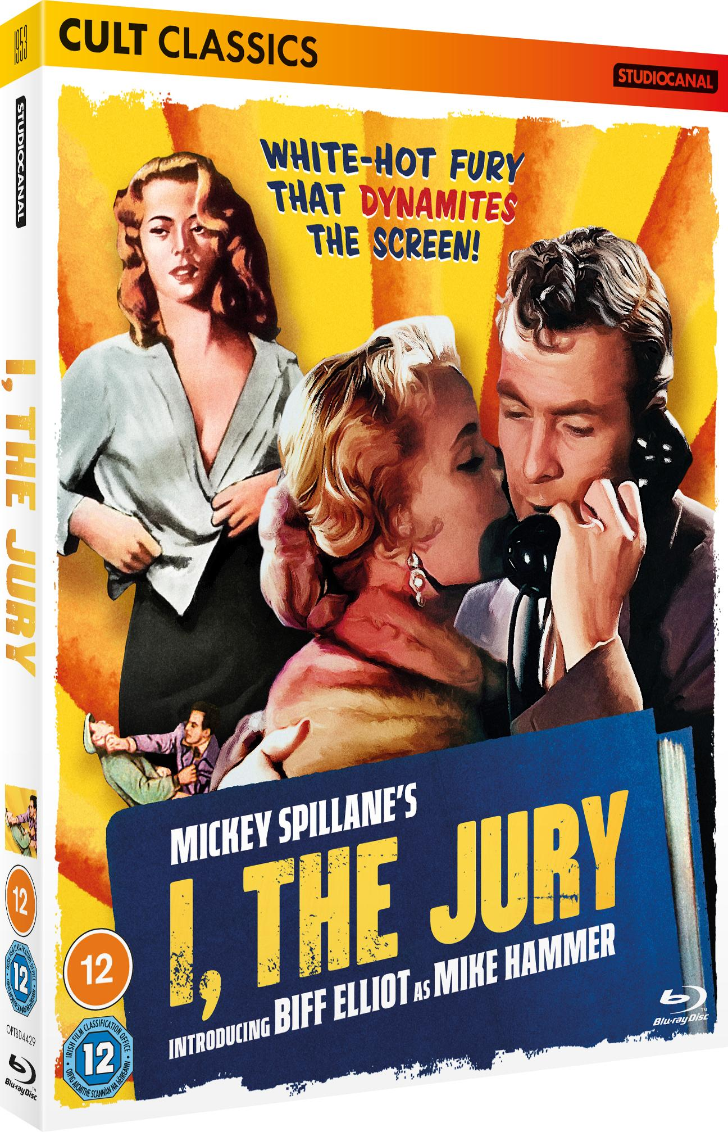

BLU-RAY, DVD & DIGITAL OUT 17th OCTOBER

STARRING: BIFF ELLIOT, PRESTON FOSTER, PEGGIE CASTLE

Discover wonderfully eccentric & eclectic titles carefully curated from the vaults of the STUDIOCANAL library, with CULT CLASSICS. The collection offers an array of genre films, Eurocrime thrillers and wonderful B movies, with more rediscovered films to be added to the range throughout 2023 and beyond.

STUDIOCANAL presents a brand new 4k restoration of the 1953 film noir adaptation of the first in the classic Mike Hammer novel series by Mickey Spillane: I, THE JURY. In the iconic character’s debut big screening outing, Biff Elliot stars as the brutal, brawling ‘one-man police department’, arriving here in digital format and indeed on tape for the very first time too.

It’s nearly Christmas in New York City but private investigator Mike Hammer is out for vengeance when his closest friend Jack Williams is murdered. Hammer vows to identify the killer ahead of the police, working his way through an increasingly large number of suspects. His starting point includes Jack’s fiancée, a beautiful psychiatrist, twin socialite sisters, and a gangster. But as he tracks them down, so too does the murderer, creating a dangerous game of cat and mouse.

Rated ‘X’ on its initial release, this gritty, hard-to-find crime thriller gem was directed by the legendary Harry Essex (who wrote genre classics It Came from Outer Space and Creature from the Black Lagoon), beautifully filmed in monochrome by Oscar-winning cinematographer John Alton, and features a cameo from Hollywood character actor favourite Elisha Cook Jr (The Killing). Ripe for rediscovery by afficianadoes of hard-boiled 1950s noir, and packed with a host of new special features, this immaculate restoration is a must-own for discerning cult film fans.

I, THE JURY is available to buy on Blu-ray, DVD and Digital from 17th October 2022, and available to pre-order HERE.

STUDIOCANAL owns one of the largest film libraries in the world, boasting nearly 7000 titles from 60 countries. Spanning 100 years of film history. 20 million euros has been invested into the restoration of 700 classic films over the past 5 years.

INCLUDED WITH I, THE JURY:
- Interview with Biff Elliot (2006)
- Audio Commentary with star Biff Elliot
- Audio Commentary with novelist Max Allan Collins

Certificate: 12
Running Time: 87 mins DVD/90 mins BD approx.
Facebook.com/StudiocanalUK @studiocanaluk @StudiocanalUK

For further information please contact:
Fetch Publicity | Tom Hewson | tom@fetch.fm

Images available from: Studiocanalpress.co.uk

About STUDIOCANAL (a CANAL+ Company)

STUDIOCANAL, a 100% affiliate of CANAL+ Group held by Vivendi, is Europe’s leader in production, distribution and international sales of feature films and series, operating in all five major European markets - France, United Kingdom, Germany, Benelux and Spain - as well as in Australia and New Zealand. It finances and produces around 30 films per year, distributes around 50 films per year and owns one of the largest film libraries in the world, boasting nearly 7000 titles from 60 countries, spanning 100 years of film history. 20 million euros has been invested into the restoration of 700 classic films over the past 5 years. STUDIOCANAL also produces more than 200 hours of TV series each year at an international level, either directly or through its award-winning network of European production companies (STUDIOCANAL SERIES GmBH, RED PRODUCTION COMPANY, URBAN MYTH FILMS, BAMBÚ PRODUCCIONES, STUDIOCANAL ORIGINAL, 2e BUREAU, SUNNYMARCH TV, SAM Productions, DUTCH FILMWORKS).

